Towards an AIDS free Paris

February 2016

Proposals to achieve the 90-90-90 targets by 2020 and end HIV transmission in Paris by 2030

Prof. France Lert, epidemiologist
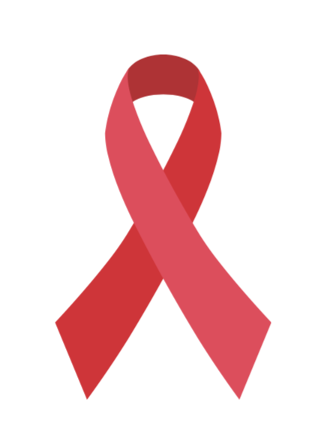
Table of contents
Towards an AIDS free Paris : recommendations to fast-track the city to achieve the 90-90-90 treatment targets by 2020 and end the AIDS epidemic as a public health threat by 2030
The mission and the Parisian committee on 90-90-90 3

Purpose 4
Collective approach 4
A positive, inclusive strategy, evidence-based and evaluated 5

Evidence-based strategy 5
Focus on sexual health and well-being 5
An inclusive strategy 5
Rooted in communities 6
Paris status in regional and national contexts 6
Sharing best practices from other countries 6
Sharing findings on the HIV situation in Paris and focusing on a sexual health strategy 6

Findings and possibilities 6
Potential of combination prevention 11

PrEP offer, experts recommendations 11
A new approach to promoting condom use 11
Simplifying access to post-explosure prophylaxis (PEP) 12
Regular screenings combining different types of tests and services 12

Testing 12
Medical facilities 12

Regular testing and comprehensive treatment for STIs and Hepatitis 13
Primary health care professionals: general practitioners and healthcare centers 13

Health mediation 16
Programs 17

People living with HIV 17
Recommendations 18

Gay men/Men who have Sex with Men (MSM) 19
Recommendations 21

Migrants from Sub-Saharan Africa and from other regions of the world 24
Recommendations 26

Transgender people 27
Recommendations 28

Sex workers 29
Recommendations 29
Implementation 30

Monitoring tools 30
A strategic committee, a forum and a coordinator 31
Agenda and priorities 31
A public-private foundation 31

The Paris Declaration, initiated by the city of Paris, UNAIDS, UN-Habitat and IAPAC (International Association of Providers of AIDS Care) and signed by Mayor Hidalgo on 1st of December 2014, commits cities around the world to give sustainable access to screening tests for HIV, to ART, to prevention tools, and to end discrimination and stigmatization. Two hundred cities have signed the declaration by the end of 2015. They commit to help each other to mobilize financial resources and take advantage of their respective experiences in terms of program implementation in order to attain the 90-90-90 objectives by 2020 (90% of people knowing their HIV positive status, 90% of people who know their HIV-positive status on treatment, and 90% of people on treatment with suppressed viral loads. The objective is to end HIV transmission by 2030. Mayor Anne Hidalgo has established this mission and the Parisian committee to reinforce leadership in fast-tracking actions to reach the targets.

As a Fast-Track City, Paris is committed to robust monitoring and evaluation (M&E) to benchmark, track, and report progress toward attaining the 90-90-90 and zero discrimination and stigma targets. Paris also embraces the principle of open data to communicate basic indicator data via a web-based city dashboard that plugs into a global Fast-Track Cities web portal made publicly available to local, national, regional, and global stakeholders engaged in ending AIDS as a public health threat by 2030. The dashboard will also allow Paris to share best practices and strategies deployed to increase the numbers of people tested for HIV, linked to care, and achieving favorable health outcomes, including long-term viral suppression for PLHIV who are on antiretroviral therapy and decreased HIV acquisition through the use of PrEP.

The mission and the Parisian committee on 90-90-90

Purpose

The objective of this mission was to determine operational strategies by taking into account the issues and needs of Key Affected Populations (Men who have Sex with Men or MSM, Transgender People, Sex Workers, Migrants and People who Inject Drugs or PWID).

A collective approach

Existing and currently available tools in Paris are insufficient to curb the epidemic, particularly in high-prevalence populations such as MSM and migrants from Sub-Saharan Africa. Physicians, community representatives, politicians and other HIV service providers recognize the urgency of a renewed approach based on cutting-edge research and most recent scientific advances. The current situation can be described as a “loss of collective opportunity” to stop HIV transmission.

In 2015, French research has played an important role in different trials such as ANRS-Temprano in Ivory-Coast, attesting that early initiation of ART reduces mortality and severely reduces morbidity, and in the ANRS-Ipergay trial that demonstrates the effectiveness of on-demand Pre-Exposure Prophylaxis (PrEP) for MSM.

Individual benefits of immediate treatment, preventive efficacy of the treatment, PrEP’s efficiency call for the redefinition and renewal of anti-HIV strategies without any further delay: “There can be no excuse” says American immunologist Anthony Fauci.

These recent innovations were translated into recommendations by international and national agencies.

These breakthroughs are well-known by Parisian HIV stakeholders.

The objective of this mission was to build a strategy tailored to the Parisian population, framed in the HIV history of the city, different actors experience, concerns of key populations, the structure of health care provision, and the city’s unique geographic location at the core of the region. More than 130 people from civil society, medical sector, health administration and the scientific community have contributed to this joint effort. Discussions led to converging viewpoints on the Parisian situation, defining the most efficient approach to articulate a comprehensive HIV combination prevention strategy.

A positive, inclusive, evidence-based and monitored strategy
An evidence-based strategy
The scientific and medical progress, the understanding of the epidemic by multiple disciplines and the expertise deriving from available data for public health and care actions shape the scientific foundation for a renewed strategy. Ongoing research will progressively provide new data that will be used to update the Parisian strategy. Research, in close collaboration with the ANRS, is a central aspect of the program described in this document to experiment new approaches, assess scale-up in the combination of methods and the epidemiological and societal impact of the Parisian program.
Focus on sexual health and well-being
Condoms are no longer the only preventive method since ARV offers a protection against HIV transmission (treatment of HIV infected individuals) and acquisition (Pre-Exposure Prophylaxis (PrEP). Yet, for most people, condoms will continue to be promoted as a major prevention tool against STIs and HIV transmission or as a contraceptive method. It is now possible for everyone to choose the method that meets his/her needs, as long as these methods are known, available and easily accessible. Alternative to condom should alleviate the burden of responsibility, guilt or denial, generated by a norm which is difficult to comply with for a growing proportion of the population, especially in the MSM community and allow for a sexual health approach of prevention. Programs should be developed and implemented with a holistic approach based on sexual health and well-being.
An inclusive strategy
Populations most affected by HIV in Paris are still being discriminated against because of their sexual orientation, skin color, nationality or origin and their HIV status. In recent years, legal and social discriminations against people living with HIV have been acknowledged as a major political issue. There have been some legal improvements, including same sex marriage but discriminatory practices persist, including for example regarding change of civil status for transgender people or denial of post-mortem conservation care for HIV infected people. Besides, restrictive legislation regarding foreigners status and sex work conditions undermine people’s abilities to take care of themselves.
According to a study conducted by AIDES in 2015, discriminatory attitude and practices are not uncommon in healthcare settings, which accentuate the need for stakeholders to actively promote and implement changes in practices and behaviors. The ideal of equality goes along with sexual health. Some urgent measures need to be amended including a position statement in favor of legal rights change, referral to the human rights ombudsman, campaigns, assessment of discriminatory practices in healthcare services, sensitive labelling of LGBTI-friendly services, training of administrative, social and health services personnel.

Rooted in communities
From the very beginning of the AIDS era, Paris has seen the development of diverse and active community-based associations which have been supported by the city council. The HIV era has seen the inclusion of community-based associations in political decision-making on HIV-related issues, in research, and the implementation of health programs. This practice fosters research and enables rapid dissemination of results so that actions can be quickly adapted to the diverse on-the-ground realities. The Parisian program will have a strategic committee comprising people from community-based associations, the scientific community, physicians and health administrations that will monitor and update the program. An annual forum will gather all the actors to take stock of the achievements and address gaps.
Paris, its regional and national environment
In the Ile-de-France region, populations come and go across Paris and its outskirts to access medical care, to work or entertain themselves. As regards HIV, for some populations exposed to stigma and discriminatory practices the diversity of services offered in Paris assures an easier and more confidential way to access these. The configuration of the prevention and care offer in the region impose to align the Parisian program with the regional needs, therefore involving the Agence Régionale de Santé (ARS), l’Agence Nationale de Santé Publique and the Ministry of Health.
Sharing best practices with other countries
The Paris Declaration unites the world's major cities with the aim to achieve the 90-90-90 targets in the spirit of learning from each other. Some cities like San Francisco have already advanced and achieved concrete results. Similarly, Paris will bring its experience and support to other cities to implement innovative programs.

Trends in HIV epidemiology in Paris

This strategy’s objective is to reach the 90-90-90 targets in 2020 to move towards the elimination of new infections and of AIDS as a public health threat by 2030.
As regards the second and the third targets, according to the French Hospital Database, 96% of people receiving HIV care were on ART and 94 % had undetectable viral load for the past 6 months, in 2014. However, the proportion of diagnosed cases among the estimated figure of HIV positive cases is only 81% with variations between populations.
The epidemiological landscape in Paris is characterized as follows:

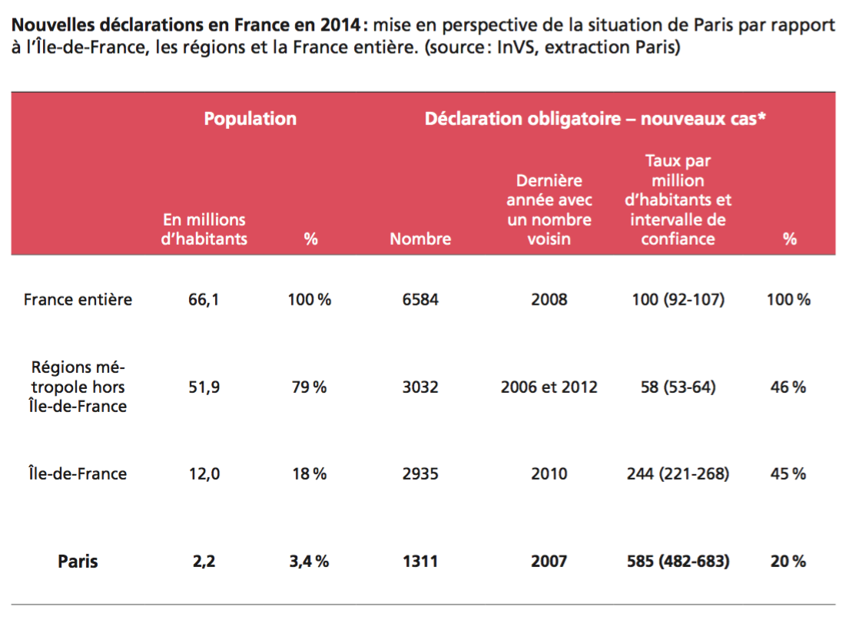
Figure 1New HIV diagnosis in France, Regions outside IdF, Ile-de-France (IdF), and Paris in 2014

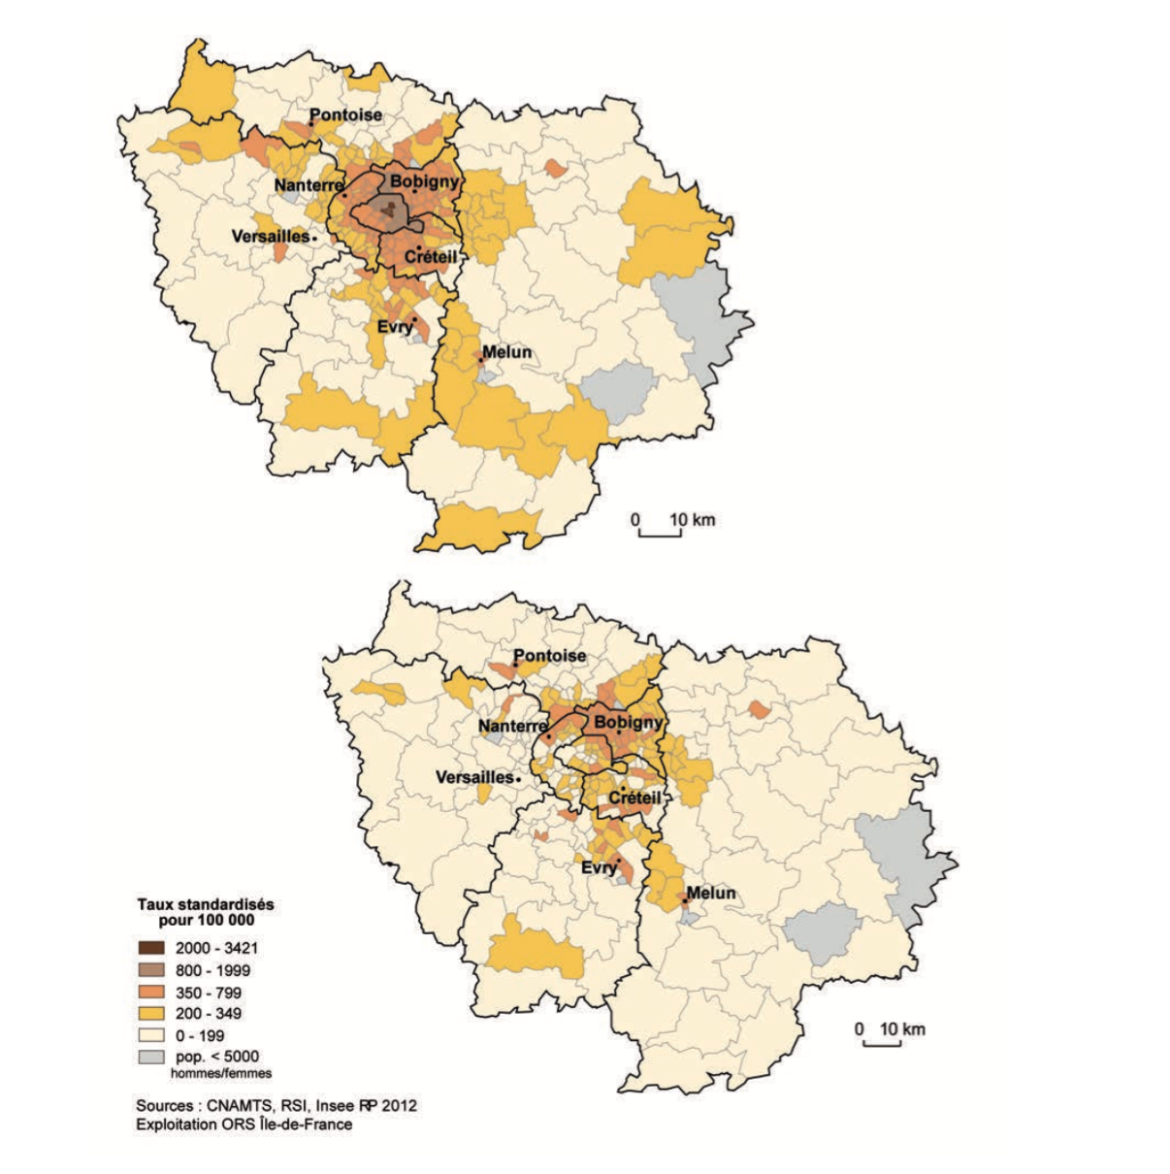
Figure 2 Standardized rate of beneficiaries of ALD* for HIV (ALD 7) in 2013 per 100 000 persons/canton or city in Ile-de-France*

Specificities of the epidemic in Paris:
- A significant epidemic: The rate of new HIV diagnoses is five times higher than the national average (585 new HIV + diagnosis in 2014 per million, 100 for the entire country), twice higher than the Ile-de-France province average and 10 times higher than the national average outside Ile-de-France. Parisian figures represent one fifth of the country’s total figures, for approximately 3% of the French population.

- A concentrated epidemic: the epidemic is concentrated in the MSM population (52.5% of newly diagnosed cases) and in migrant populations particularly from Sub-Saharan Africa through heterosexual intercourses (38.3%). The number of new cases among people who inject drugs (PWID) has sharply decreased (fewer than 15 cases in 2014). The most pressing issue for PWID is hepatitis C infection and access to effective treatment.

- A concentrated epidemic in terms of geography: health insurance data indicates that 17 501 people receiving full reimbursement for HIV care were living in Paris in 2013 (3.586 women and 13.915 men), with an increase of 3.800 between 2011 and 2013. The map established by the Regional Health Observatory pinpoints the geographical heterogeneity of the prevalence based on the number of beneficiaries per population per canton and cities in Ile-de-France, and for Paris per Parisian arrondissement (borough). The epidemic is concentrated in the 1st and 4th arrondissements (the gay district) and the North-East (10th, 11th, 18th, 19th, 20th boroughs with large migrant communities) but also the 13th.

- An increasing epidemic: New HIV diagnosis figures have increased among MSM with a maximum in 2014 compared to 2003 when Mandatory Reporting of new HIV cases was established. A decrease has been observed in other groups with a small increase among foreigners in 2014.

The high frequency of late diagnosis weakens the impact of treatment as a preventive measure to reduce HIV transmission. Diagnosis at late stages of HIV infection is still high but decreases continuously. However early diagnosis after transmission (characterized by the primo-infection at diagnosis or an infection less than 6 months before testing) has achieved insignificant progress in the last few years.

Nevertheless, the decreasing rate of AIDS cases corroborates the decrease (even insufficient) of late diagnosis and the efficacy of ARV treatment. This decline is particularly noticeable in Paris (the city accounts for 12% of the national figure of AIDS cases as compared to the 20% of new diagnosis observed in France).

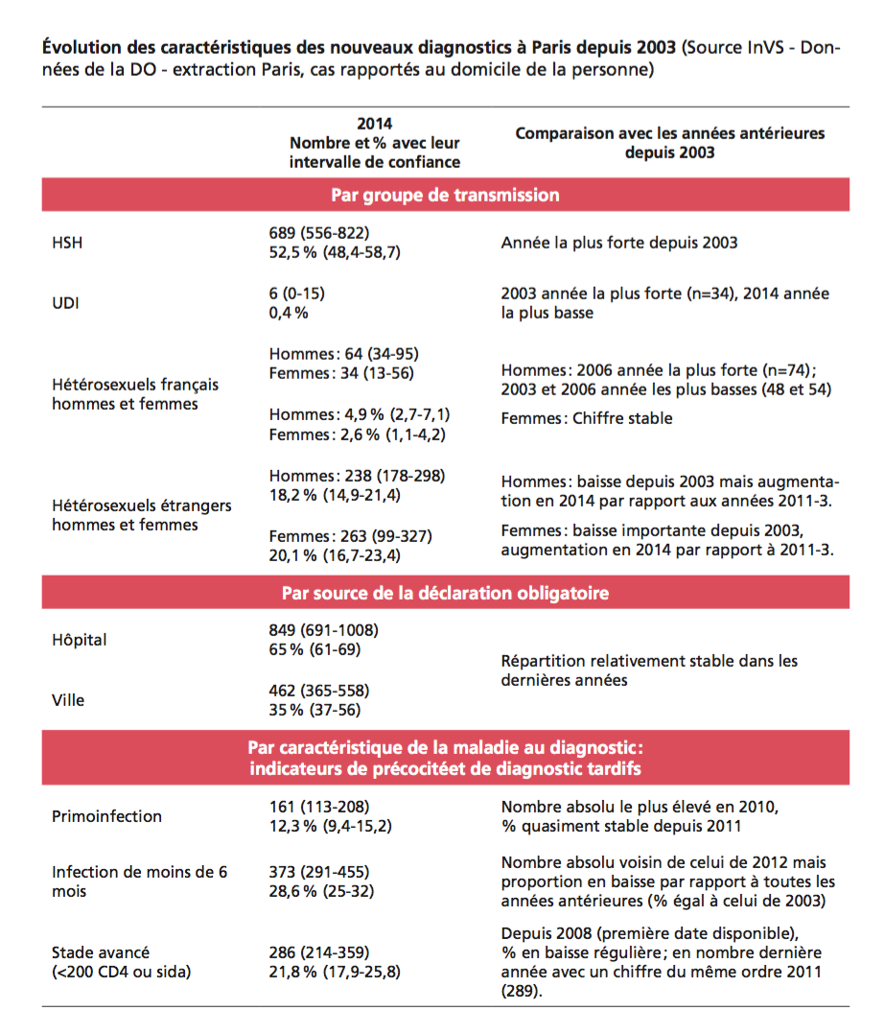

Paris offers a very diverse range of healthcare services with 11 services in public hospitals (AP-HP) which are also clinical research facilities, 11 STIS clinics, CeGIDD (Centres Gratuits d’Information, de Dépistage et de Diagnostic), 8 mobile programs of community-based testing deployed throughout Paris available for different groups; several others to be approved soon, a health center that proposes sexual health services to MSM (“the 190”), walk-in centers like Institut Alfred Fournier, and several community-based associations proposing a range of different activities.

Combination prevention

Combined prevention hinges on renewed information and clear messages on testing, treatment and its preventive effectiveness, promotion of condom use and PrEP, control of STIs and comprehensive care of HIV-infected individuals. Combined prevention tools are similar for all concerned groups but their conjugation will build adapted programs for different populations according to epidemiology and sexual lifestyles.

Offer PrEP, experts recommend

TRU’s approval (Temporary Recommendation for Use), the decision to reimburse Truvada and associated medical costs, the engagement of specialized hospital services to provide PrEP and the possibility in a near future for prescriptions in STIs clinics will make PrEP available to the groups at higher risk of acquiring HIV. In October 2015, the experts’ committee led by Pr. Morlat developed the guidelines, the framework of prescription, and medical and biological follow-up for the different populations. Currently, these recommendations suggest limiting PrEP offer to the fraction of MSM populations who are the most exposed and to other populations based on individual exposure level. However epidemiological data encourages relying on PrEP to meet the anticipated objective, particularly for MSM. This calls for a rapid scale up in terms of PrEP offer, strong and wide communication campaigns, and special vigilance in this population as long as a sufficient number of men on PrEP is not reached.
A new approach to promoting condoms
Recommendation on PrEP leaves great scope for condoms, which are the only method for the majority of people to protect themselves from HIV and STIs. It is therefore essential that its accessibility and acceptability remain strong so that those who are willing to use them can do so. This calls for a new approach to promoting condoms through a sexual health perspective: strong efficacy, self-control, quality of products, variety of sizes, material and packaging, and low cost.
Simplifying post-exposure prophylaxis access (PEP)

Until now, PEP has been proposed by HIV specialized services in hospitals and emergency services. In the near future, it will be authorized in STIs clinics. The scale of its use is not documented. PEP, which has been promoted lightly thus far, will be more widely encouraged. PEP users will be assessed as regards their need for pre-exposure prophylaxis (PrEP) and, when necessary, it will be proposed to them or they will be referred to relevant services.

Regular testing combining different types of tests and services

To date, the testing strategy has not delivered its expected outcomes. Scope for progression is high for TasP, with the reduction of time between transmission, diagnosis and viral replication control thanks to treatment.

Messages regarding testing for the most exposed populations could be simplified. The three types of available tests (self-testing, rapid test, and 4th generation Elisa test) are technically and biologically efficient and can be used indifferently as long as a clear message on primary infection is given. Individuals with a recent exposure or symptoms of primary-infection (not completely detected by rapid tests) should be advised to consult a doctor using 4th generation Elisa test or viral load testing.

The objective of early testing requires repeated and regular testing for the most exposed populations: every three months for MSM who are sexually active regardless of their number of sexual partners.

Testing would also benefit from wider utilization of rapid testing tools compared to the recommendations of the Haute Autorité de Santé (HAS) in 2008, in healthcare facilities and testing centers, in order to encourage and ease testing, and optimize human resources through task-shifting (to date, in France, counselling should be delivered by a physician).

Medical facilities and measures

STIs clinics (CeGIDD) join the missions of former CDAG and CIDISST (CDAG: Anonymous and free-of-charge HIV testing centers; CIDDIST: Information, Diagnosis and Care centers for sexually transmittable diseases). An approved centers’ list in Ile-de-France region was published in December 2015. Coordination of STIs clinics should be improved to secure access for each and every population. It is of utmost importance that CeGIDD be prepared to take care of HIV positive people for their sexual health needs (promotion of ART efficacy, STIs testing and treatment, counselling for partners etc.) who are less likely to seek hospital services.

Since 2011, community testing within community-based associations’ facilities or in public in-door or out-door places has been growing stronger and showing promising results in terms of attendance from people who had never been tested and from the most exposed populations (30% for MSM, 28% for migrants and 36% for other populations). With respect to national testing figures, community testing shows a higher rate of positive diagnosis compared to other systems (60 000 tests among 5 million for 500 new HIV + cases in 2014), including anonymous testing services, all of them appealing to the most exposed populations. Nevertheless, community testing is ill-funded (subsidy calculated on the number of tests done amounting to 26 €), with a price that does not cover the necessary activities for a good organization of testing campaigns (exploration of sites, consultation among community-based organizations, support for people, evaluation etc.).

Community testing should be scaled up with proper financing and a robust strategy in terms of location, populations and the collaboration between different community-based organizations representing the needs of specific populations. Follow-up and mapping are implemented by the ARS.

Self-testing has the potential to produce positive effects and address the needs of specific populations adequately. Its current high price can be an obstacle and its distribution by community-based organizations has not started yet due to budget restrictions. With the support of UNITAID, various possibilities will be explored to acquire a significantly high number of self-testing kits and reduce cost. In the upcoming years, other testing tools such as saliva-test will be approved by health authorities widening their utilization and easing their access to a broader part of the population. The use of self-testing and its impact is currently under investigation through ANRS/V3T project (HIV: Teste-Toi, Toi-même).

Home based self-sampling has been successful for the INPES – Chlamyweb initiative (testing through internet, shipping of a self-sampling kit, samples delivered to a laboratory, results through text messages or phone call). A new study is being developed under the supervision of INPES in the general population associating HIV, HVB and HVC testing for 15 000 individuals. Another project is being strategized by the INPES to propose self-sampling for HIV and STIs to MSM. In the United Kingdom, Public Health England has implemented a similar system for HIV and private initiatives were taken as regards other STIs.

Regular HIV, STIs and hepatitis
Since the early 2000s, STIs have been continuously increasing, particularly among MSM populations and more specifically among HIV positive men. Comprehensive and systematic testing of STIs in STI clinics, sexual health centers, and HIV specific services with a varying periodicity depending on populations needs to be implemented. New recommendations in terms of prevention, testing, and treatment regarding STIs in different populations and age group are much needed as these are marginalized aspects of sexual health.
Primary healthcare: general practitioners and healthcare centers
Primary healthcare services, general practitioners, outpatientclinics, drop-in medical services for the most deprived (PASS), are in direct contact with the most vulnerable populations in certain Parisian boroughs.
A survey conducted in 2013 and involving 477 general practitioners in Paris reflects the geography of the epidemic in the City. It indicates that more than half of the respondents, namely in the North-Eastern and the central areas of Paris, have more thant 10 HIV positive patients in their caseload and/or have prescribed more than 10 tests during the last month. It also reveals that younger physicians, female physicians, and those in sector 1 (basic fees) prescribe HIV tests more often. The survey underlines that less than half of the practitioners are aware of the 2009 HAS recommendations and their activities indicate several missed opportunities of HIV testing/diagnosis.
General practitioners make 35% of the total of new HIV cases mandatorilly reported in Paris. Physicians and primary healthcare services have an important role whereas HIV has a limited share in their overall activity given the specialized follow-up in dedicated hospital services, with the exception of a small number of dedicated physicians ensuring the follow-up of HIV positive patients in their caseload.
Centers receiving precarious populations, most of them undocumented foreigners, have systematic testing practices improving early diagnosis. Besides it has been nearly impossible to implement the recommendation of generalized testing made by the National Program 2010-14. The number of tests has increased but figures on mandatory information from GPs has stalled or declined. Only late diagnosis has declined. This situation, which is not exclusive to Paris, suggests that information and recommendations must be refined, targeting health care practitioners and service providers, especially in the hardest hit boroughs.

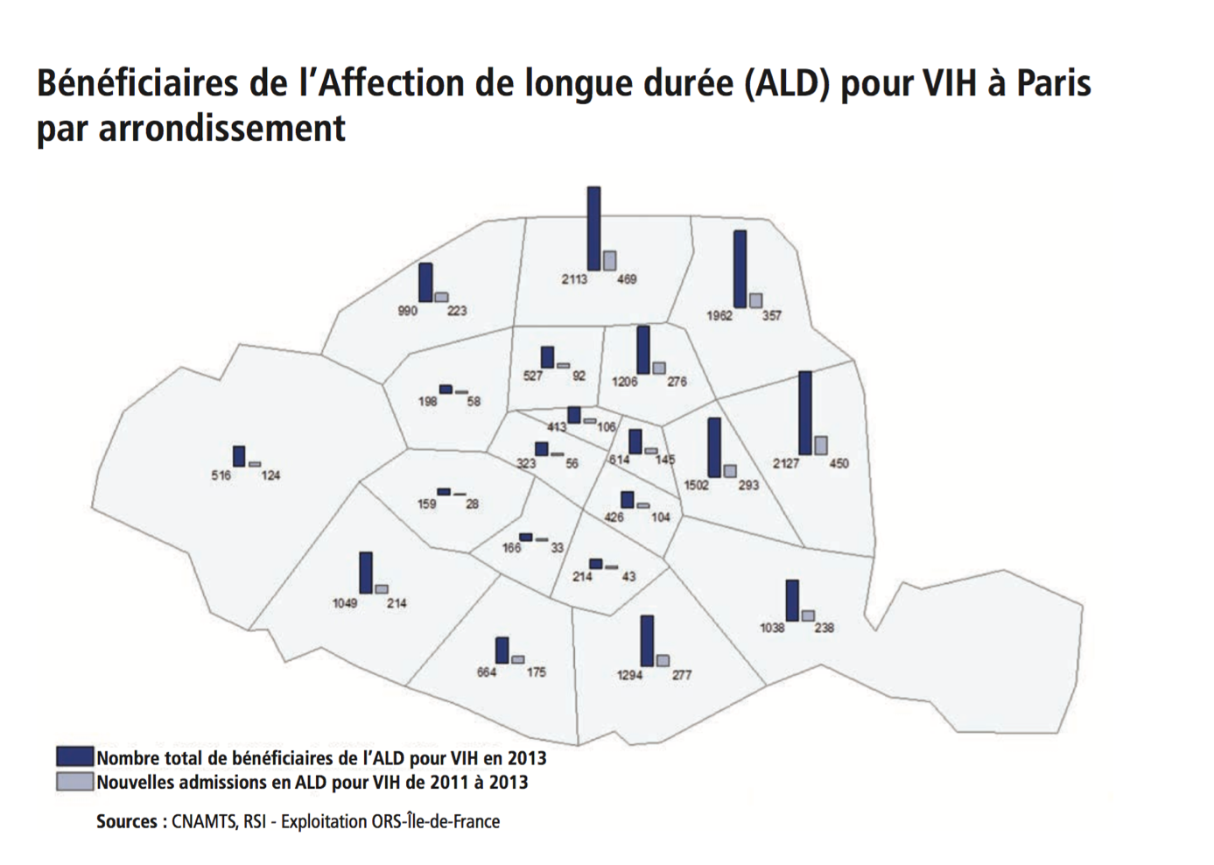
Figure 3 Beneficiaries of long-term illness exemption (ALD) for HIV by arrondissement in Paris

- Disseminating adequate information and recommendations with regards to the geographical distribution of HIV cases in Paris (figure 3).

Recommendations for primary care services should be disseminated by the CPAM (national health insurance service), City health services or the Agence Nationale de Santé Publique - Santé Publique France (Public Health France). This document will mention localized epidemiologic data, recall symptoms or pathologies that call for HIV testing to avoid missed opportunities. Regular testing for the most exposed populations (including migrants from Sub-Saharan Africa) will be recommended. Physicians will be encouraged to immediately refer newly diagnosed patient to specialized services in order to ease their linkage to care and immediate treatment. Rapid test tools could be distributed to practitioners and health care service facilities in need. This program towards GPs and primary care centers should be strengthened via face-to-face appointments with physicians and service providers in the most concerned areas of Paris. Information will also be disseminated to biologists throughout the city since it is possible to request testing directly from analysis laboratories.

- Including general practitioners in the care strategy

In the upcoming years, medical follow-up of HIV infection in dedicated services will be less frequent and general practitioners, particularly those in North-Eastern and central boroughs of Paris will have an increasing number of people living with HIV to take care for their health problems. The care of these people will require renewed links between general practitioners and specialized physicians in hospitals, as it is already the case for several severe and chronic diseases. For HIV, modalities of care should be updated. One of the new missions of STI clinics (CeGIDD) is to provide training and counseling services for health professionals in their respective geographic area of activity.

Primary healthcare service providers will be represented in the steering committee of the Parisian Program.

Programs for specific populations

In 2014, as indicated above, 90% of new HIV infections occurred among MSM and Sub-Saharan migrant populations. Other populations such as sex workers and transgender have specific health needs, particular regarding sexual health and access to rights and care, for which HIV can leverage a comprehensive approach. These groups are represented by different community-based organizations. Emphasis on prevention and strong individual and population efficacy of treatments should not weaken the focus on HIV positive people’s needs in terms of sexual health and social inclusion. Hence the Parisian program will be centered on common principles and divided in specific programs proposing different priorities and combinations for the different populations: PLHIV, MSM, migrants, transgender persons and sex workers.

In this report, specific measures for people who inject drugs (PWIDs) have not been developed. Nevertheless, drug users have paid a very high price for AIDS as they were affected by the epidemic, early and massively and most could not benefit from triple-therapies from 1996. The decision of Michèle Barzach to free the sale of syringes from 1987, the mobilization of the HIV community in favor of PWIDs, its commitment to limit damages and compensate drug specialists’ blindness at the time, have allowed for the full deployment of harm reduction policies since 1995. Today, new HIV infections among PWIDs are rare in Paris (15 in Paris in 2014). The harm reduction program is of utmost importance in all social and medical aspects, with the aim of preventing HIV and hepatitis C: the establishment of a drug-consumption room, the ongoing “low-threshold” programs, the implementation of new strategies to teach on safe injection practices or to prevent injection initiation, and above all, access for PWIDs to VHC antiretroviral treatment for individual and collective benefits.

People living with HIV (PLHIV)

Today, 96% of PLHIV on care receive ART and 94% have reached viral suppression. These excellent results can be slightly overestimated due to temporary interruptions in care for some patients who are subsequently invisible for statistics. ART enables a life with little impact on physical health for the large majority of PLHIV and a life expectancy that is similar to the general population for those who have more than 500 CD4. Nevertheless, some still suffer from the long-term consequences of the disease, while others are diagnosed at a late stage and see their health altered durably. With time, treatments come to be more and more tolerated, simpler, and other innovations are currently being developed (simplified treatment, long-acting treatment, relief schemes etc.). The frailty of age brings new burdens with the onset of comorbidities. Their frequencies, intensities and etiologies are not yet fully comprehended.

Hospitals are central to access to care for HIV infection, with more and more distance between medical follow-up (6 to 12 months when the health condition is favorable), fostering the integration of new strategies or therapeutic molecules related to clinical research advances. This hospital-centered approach calls for a particular attention on PLHIV’s health path, in order to take care adequately of other and common health issues, comorbidities and sexual health needs. This is the reason why projects have emerged, on hospital alternatives, importance of information from general practitioners and a truly open sexual health service for people living with HIV.

The social aspects of being HIV infected did not witness the same progress as the medical ones. Setbacks in terms of disability acknowledgement linked to the amelioration of health condition has been translated into increasing unemployment among PLWHIV and compared to the general population, the level of insecurity and poverty is higher. Social and personal life is affected by discriminations linked to the HIV positive status, sexual identity, racism, xenophobia and other forms of discriminations in all aspects of daily life. The rejection and fear of rejection and weakening self-esteem are altering social, affective and sexual relations.

The undisclosed secret about the disease, the physical distance with relatives for multiple reasons, isolation, and other after-effects deriving from traumatisms are frequent and depression is high among PLHIV. One of the HIV care coordinating body in the region, COREVIH Ile-de-France East, is conducting a regional survey on support needs with a specific focus on risks of interruption in the care continuum and on the situation of patients with a complex profile.

Such situations have been reported by community-based organizations in Paris, during PLHIV support meetings.

Text drafted by Basiliade, ARCAT and Aurore to account for complex profiles
- Accumulation of multiple pathologies, often chronic and evolving, implying multiple medical follow-ups with different specialists, and requesting coordination between different health actors. These pathologies are often associated to other health issues (exhaustion, pain, loss of mobility etc.).
- Mental issues, addictions.
- Pathologies and health issues impact on daily routine and professional activities.
- Social isolation and lack of social interaction.
- Lack of specialists.
- Poor living conditions and social and administrative difficulties.
- Social and medical challenges prevent access to care and increase the number of people lost to follow-up in Ile-de-France.
- Lack of social-medical-psychological coordination and comprehensive follow-up covered by the “Etablissement Sanitaire et Medicosocial” (ESMS) program.

Associations report unfair practices and harassment from health and social welfare organizations. These difficulties exacerbate the vulnerability of the most fragile populations.
Recommendations
National recommendations are included in the chapter « Living conditions for a therapeutic success » of the Morlat experts’ report.
Recommendations to improve health and quality of life of PLHIV are:
- Reduce administrative obstacles that prevent access to rights at the prefecture and other social administrations with greater city involvement.

- Support alternatives to hospital care for PLHIV. General practitioners, “the 190” healthcare center, and the Institut Alfred Fournier provide comprehensive outpatient care and services. In some boroughs more than half of the GPs follow at least 10 HIV positive patients, which call for stronger links with specialized services. The Paris Saint-Antoine’s hospital team has proposed creating a comprehensive multidisciplinary health center, to treat chronic viral infections contributing to healthcare providers’ professional training.

- Associations providing support to vulnerable populations also propose « home-based medical » coordination.

- Stronger message on the preventive effectiveness of ART.

- Promote open dialogue among sero-discordant couples and the benefits or ART as a preventive measure, sexual disorders, STIs and comprehensive sexual health programs.

- Prevent care interruptions and identify those who have no access to care.

- Promote alternative programs to patient treatment ‘education’ in hospital settings: comprehensive community-programs, including sexual health and peer-to-peer education, on different chronic diseases.

- Support long-term health mediation across services or community-based organizations to support most vulnerable populations.

- Support PLHIV led community-based organizations and communal spaces including voluntary counselling and testing (VCT) services, use existing measures, laws and policies to fight discrimination.

Men who have Sex with Men

Gays and MSM are populations at high risk of acquiring HIV.
The HIV epidemic disproportionally affects gay and MSM populations in big metropoles. In 2014 the epidemic soared in Paris. The epidemic trend may accelerate because of undiagnosed HIV cases among gay and MSM populations characterized by frequent unprotected sex with multiple partners. Compared to the rest of the country, Paris has an alarming high prevalence (at least 20% for MSM), associated with specific sociological features. At national level there has been a sharp increase in new HIV infection cases among young people aged between 15 and 24 (no precise numbers for Paris).
The epidemiological landscape is also characterized by the rise in STIs in the past 15 years closely linked to changes in lifestyle and behavior such as dating applications and websites, or chemsex.
Characteristics of MSM populations in Paris, compared to those in the inner suburbs and outer suburbs in the region (Source: EPGL, 2011, Annie Velter, InVS).
Among the participants to the Enquête Presse Gays et Lesbiennes survey (2080 participants), Parisians are older than MSM in the rest of the country (median age of 38), they have higher education (67% are graduated vs 37% in the inner suburbs – 636 participants, 49% in outer suburbs – 878 participants and 40% in other French departments (6726)). They identify themselves as homosexuals (91% vs 84%, 86%, 86%) and have exclusively had male partners in their lifetime (64% vs. 64%, 60%, 59%). They routinely access backrooms (73% vs. 5I%, 60%, 57%) or saunas (46,5% vs. 41%, 43%,42%).
There is little difference in the use of internet according to the area. Parisian gays have more male sexual partners: a median of 9 per year for Paris, 5 for the inner suburbs and 4 for the outer suburbs and other departments. Among Parisians, men aged over 35 have more partners than younger age groups (A median of 10 vs 6 for 30-34 years old and 5 for 25-29 years old).
Parisians test for HIV more than MSM of other areas of France. They are more often identifying as HIV positive (24 % vs. 11,1 %, 15,9 % et 12 %). These HIV positive men have a median of 20 sexual partners per year, compared to those declaring themselves HIV negative (5).
Among the HIV negative who underwent HIV testing, 64% of Parisians have done a test in the past 12 months. These men have a median of 10 sexual partners a year.

With regards to unprotected anal intercourse with a sero-discordant partner or a partner with unknown status in the past 12 months (37%), there is no difference according to place of residence. The observations according to HIV status do not differ significantly in the region. For Paris, 60% of HIV positive men reported an unprotected sexual intercourse in the last 12 month period.
Despite a more accessible testing offer, thanks to the multiplicity of testing centers in Paris (in 2011, community-based testing centers were beginning to be established), the level of testing the past 12 months do not differ in Paris as compared to other departments. In the most recent data, there is no significant increase of diagnosis at early stages of infection.
Despite a strong presence of community-based organizations, care and prevention services, incentives for testing and ARV initiation after diagnosis, the situation did not improve.
- Consensus for change
From 2010 to 2015, PrEP’s effectiveness has been questioned in the gay communities and by a significant share of health professionals, raising ethical issues in the ANRS-Ipergay trial, doubting PrEP’s effectiveness in real life, emphasizing the risk of undermining the importance of condom use, increase of STIs and Hepatitis C, disempowerment, medicalization of sexuality, dependency of pharmaceutical industries, and high cost.
Stronger evidence and the calls from scientific community leaders have helped shift opinions. Actually, after the results of the Iprex trial in 2010, showing the moderate effectiveness and emphasizing the importance of adherence, PROUD and ANRS-Ipergay trials, carried out in London, France, and Canada respectively, showed strong effectiveness (86%) in controlled environments with two different study designs. PreP is now recommended by WHO guidelines (2015), the European AIDS Society (EACS in October 2015) and the European Center for Disease Control recommendations for MSM in April 2015. France is the first European country to authorize PrEP as an accessible and affordable prevention tool: recommendations of experts (eligibility criteria, prescription and follow-up ;9th of October 2015), decision of a RTU by the Agence Nationale de Sécurité du Médicament (ANSM, 29th of October 2015), decision of French Minister for Health, Marisol Touraine (23rd of November 2015), favorable vote by the InterLGBT (November 2015) and finally the effective availability of PrEP from January 2016.
However some people still express reluctance towards such a change. This dynamic is similar to past ones on « therapeutic optimism » regarding tri-therapies (1996), and PEP (1998). A minority of members of the Parisian Committee on 90-90-90 expressed serious concerns about the impact PrEP may have on condom use as an effective prevention tool, excessive enthusiasm, and fear of increase in STIs. They mention the intervention heavily targets a population at higher risk of acquiring HIV, exposing MSM vulnerability and homophobia and potentially having a negative impact on their sexual lives.
- Deep-rooted homophobia
Undeniable progress is needed to end discriminations based on sexual orientation. In 2006, in the French general population, one out of five young people believed that homosexuality was against nature and (“only” 10% of young women agreed). Political parties’ homophobic discourse and behavior during the parliamentary debate on same-sex marriage shocked the LGBT community. Young homosexuals face homophobic pressure at school, as adolescents, and at home. Suicidal tendencies is a major concern among young LGBT populations, and LGBT rights are a critical component of sexual health and the global AIDS response in Paris.
Recommendations
A comprehensive approach
The epidemiological situation calls for a more optimistic, renewed and attractive prevention paradigm directed towards gay and MSM populations, supported by comprehensive services including PrEP, sexual health and the promotion of sexual and mental well-being. Preventive measures should include accessible and affordable PrEP, condom use, regular testing, STIs’ testing and care. No new prevention dogma is to be imposed on populations, but real efficient options for effective and accessible interventions and tools will be made available.

HIV stakeholders in Paris have agreed to adopt a holistic approach to deal with the health of gay men, focusing on the« happy to be gay » message and the right to have a healthy sexual life free from HIV acquisition fear. This program should include:

- Promotion of gay life-style in its diversity, strengthening the feeling of belonging to a community and self-esteem.
- Mobilization of the gay community on mental wellbeing and related issues.
- Individual and collective attention and care of mental health issues by trained professionals, psychiatrists and psychologists, trained on homosexuality issues. They are already mobilized in existing networks (ESPAS, Psygay) or testing and care centers (the “190” and the Kiosque), or within the framework of activities developed by the Centre Gay et Lesbien in Paris.
- Community actors and professionals training in friendly services for MSM.
- The development of an online mental health program. All these dimensions are yet available in Paris at community level, within gay-friendly professional networks. These measures should be organized, developed and sustained by the Human rights Ombudsman, Public Health France, community-based organizations and health professionals.
- Developing/ implementing a risk reduction approach to ChemSex.
- The development of an online mental health program, especially targeting illicit drug consumers and slammers.

Clear communication about PrEP
Clear communication is essential to shift the prevention paradigm especially at the beginning of the program. It is important to disseminate clear information on PrEP and the medication availability and accessibility in Paris with combined messages.

- The formulation of a positive message: “prevention changes, the one you want does exist. Get informed and make a choice”.
- Disseminate strong communication messages addressing key populations’ concerns, particularly those of MSM.
- A comprehensive information package prepared by community-based organizations (SIS, AIDES, Le Kiosque, Act Up Paris) and Public Health France.
- Interactive digital communications tools.
- Regular public events for MSM populations jointly organized by community leaders and scientific and medical professionals.
- Promotion of new messages by field actors working on prevention and testing (ENIPSE, AIDES, Le Kiosque).

PrEP availability
The expert’s committee and the Truvada RTU have defined PrEP as an additional and/or complementary tool for every individual at high risk of acquiring HIV in a diversified prevention strategy. For MSM, cases of unprotected anal intercourse with at least two partners in less than 6 months or multiple STIs or the uptake of PEP in the last 12 months or illicit drug use are indicators of prescription.
In Paris, these criteria apply to a large proportion of sexually active MSM, at least at some point in their lives, suggesting the need for a large-scale PrEP dissemination. This is of utmost importance as incidence is high; there is inter-generation sex, between residents of different regions and countries, and between men with diverse lifestyles. It would be risky to propose only a condom-based prevention for the majority and keep PrEP for a core group of limited individuals who are at higher risk of HIV acquisition. The scale-up of the PrEP offer is therefore a priority in the AP-HP services, STI clinics (CeGIDDs) and Sexual Health Centers. The agenda of this scale-up is to be set up with the ARS, physicians and community-based organizations. The ANRS-PREVENIR project will bring key elements to understand the scale up and the outcomes at the individual and epidemiologic level.
Condom promotion
The use of condom has decreased in France as it has globally, according to the EPGL-2011 study. It is used systematically by 55% of HIV negative MSM, by 22% of HIV positive MSM with suppressed viral load and 13% of those who have a detectable viral load. Every sexual risk reduction brochure includes condom use as an effective preventive measure. Its impact to prevent HIV acquisition or transmission is undeniable even if some still voice negative opinions.

A British study led by professor Andrew Phillips estimated through a modelling that if condom use had been interrupted in 2000, HIV incidence would have been increased five-fold between 2001 and 2006 (=424%) compared to what was observed. The repeated testing strategy and direct treatment without condom use decrease would have diminished the incidence by three.
It is necessary to continue promoting condoms on renewed grounds. Nonetheless, one should not expect a strong impact on the inflection of epidemic trends. Condoms are available during campaigns, in STI clinics and distributed by ENIPSE in saunas and sex-clubs. The standard freely available type of condom has faced some complaints. The only way to satisfy users is to buy adequate condoms adapted to individual needs. The renewed promotion of condoms should focus on security, quality control and the consistency with individual needs: “There is always a condom that suits you”.
Testing every 3 months
The epidemic is amplified because of undiagnosed cases with a strong transmission during the primary infection phase. In the United Kingdom, to reduce the incidence to 1 for 1000 in this specific population, Phillips has calculated that the country had to identify 90% of new HIV infections in a year (testing), a bit far from the 60% today. HAS’ 2009 recommendation, still valid in France, is to test at least annually. This periodicity is too long for populations where multiple partners are quite frequent (a median of 10 partners per year in Paris) and where open relationships and extra-marital relations are common (49% of MSM in France in the EPGL-2011 investigation). A periodicity of 3 months for every sexually active MSM with an immediate recourse in case of signs of primary infection or indication of clear exposition has been agreed during discussions. Articulation between testing and orientation towards PrEP is also essential during counselling. PrEP request and medical visits every three months are also opportunities for HIV testing, particularly for the most exposed men.
Reaching out to young gay men
During meetings, participants highlighted the importance of communication modes and relationships trends among adolescents and young men attracted to men, and the disconnection with existing messages disseminated in the gay community. Young gay men underestimate exposure to HIV and have little or no participation and involvement in LGBT issues. Despite its efforts, the Parisian Committee on 90-90-90 was not able to include associations of young LGBT, except Caelif Etudiants LGBT, a federal students association from Ile-de-France. The increase of new infections among young people below 25 calls for a targeted strategy, beginning with students in universities and post-secondary schools both on-site and online. The aim is to involve, mobilize and empower young people to actively prevent acquisition and transmission. Tony Jeune Gay application developed by CRIPS in Ile-de-France is a good example (http://www.lecrips-idf.net/miscellaneous/tony-web-application.html).
A risk-reduction approach to ChemSex
In France, practices associating sexual intercourse and psychoactive substance use are a great deal of concern among physicians and community-based organizations working with MSM populations. They trigger a drop in vigilance, leads to sexual transmission of HIV and STDs, including hepatitis C through the re-use of syringes or straws, and abscesses, and possibly leading to addictions. AIDES led an investigation on such practices, an embryonic anti-addiction support has started (consultations at the “190” healthcare center), prevention brochures (currently being prepared by the Kiosque), and experience sharing with actors working on the field, on harm reduction (RESPADD, AIDES), drug users and addiction specialists.
All is ready to develop a joint harm reduction response between health care providers and addiction specialists, preventive counseling, a “slammers” forum and anti-addiction orientation.
MSM sexual health services

The principle of universal care should ensure that sexual health services for MSM meet their needs. Dedicated services should be financially supported to meet the needs, and services offered that combine care and prevention.

Migrants

The epidemic among migrant populations is an issue for Paris, the Seine-Saint-Denis department and other areas of Ile-de-France (cf. ALD map). The social situation of HIV-positive migrants from Sub-Saharan Africa is much harder compared to non-migrants living with HIV in France. A major issue is the impact of restrictive policies on undocumented foreigners.

Diversity of situations and vulnerabilities
Among new HIV infection diagnoses reported in Paris, foreigners born outside of France represent 38% of all cases, , with a slightly higher number of cases for women (263 vs 238 in 2014). Paris and Ile-de-France regions have respectively witnessed a decreasing trend since 2003 and a small increase in 2014. The ANRS-Parcours study findings showed that HIV acquisition among Sub-Saharan Africa migrants were indirectly linked to harsh living conditions, particularly lack of a stable housing post-migration. a significant proportion of new infections happened while in France (49% for men, 35% for women). Diagnosis appear earlier when migrants attend services accessible to vulnerable populations (COMEDE, CASO of Médecins du Monde, PASS, Social and medial permanence of city’s health centers), or during hospitalization for men and pregnancy for women. However on the whole delayed diagnosis is common in Sub-Saharan migrants.
Migrants living with HIV face greater financial, social and professional challenges, compared to HIV positive non-migrants. Such challenges are exacerbated by restrictive policies that make it impossible for them to acquire a resident status, jeopardizing their economic and professional integration.
Social crisis and foreigners’ rights
Immigration has been under the spotlight for a few years in France and in the European Union. Major political parties question foreigners’ rights to reside in France and to equal access to health, among others “Observatory for Foreigners Rights to Health (Debré and Chevènement) » (1997 and 1998) and the medical insurance for undocumented foreigners (AME) created by the Aubry Law with the Universal Health Coverage (CMU) in 1999. A restrictive revision of these measures is currently being adopted in the Parliament.
During discussions, community-based organizations coordinated by the Observatory for Foreigners’ Health Commission reported the existence of unlawful administrative practices from administrations delivering residence permits in Paris.
Irregular practices have been reported by participants in the meetings.
Recommendations

Provide combined prevention tools to Sub-Saharan African population, improve their living conditions through sustainable access and availability.

Fight poverty and improve access to care

Universal health insurance has taken the commitment to fully implement the Parisian Pact framework and process the Public Medical Help (AME) requests within 30 days.

Support community-based organizations engagement

One of the most effective forms of reaching out to Sub-Saharan communities relies on the mobilization and engagement of community-based organizations (CBOs) such as AIDES and Afrique- Avenir and other organizations supporting community efforts: events, associations based on regional identity or country of origin etc. Sustainable and effective improvement of Sub-Saharan African communities’ health is dependent on CBOs services.

Combination prevention strategies

Combination prevention measures play a key role among people living with HIV, within these populations, even more as they are diagnosed late. People who migrated to Paris recently should have easy and quick access to voluntary and regular testing, particularly men, who tend to seek health services less regularly than women. The recommendation is to combine outreach testing and primary healthcare services.

PrEP is recommended for heterosexual populations on an individual basis. Migrant women who arrive in France alone are particularly vulnerable, suffering from administrative restrictions of their rights, leading to lack of empowerment and resources to negotiate sex and condom use. In such cases PrEP could be introduced and adopted as a preventive measure. PrEP is recommended as an additional protection measure for sero-discordant couples, on a case by case basis through specialized services and STI clinics.
Comprehensive sexual health approaches
Needs for this population include access to a robust sexual health approach combining testing (HIV, hepatitis etc.), vaccinations, contraception, pregnancy follow-up, concerns regarding infertility, HIV prevention including PrEP, prevention and repair of female genital mutilation.

Transgender people
The diversity of personal pathways of transsexuality and self-definition leads us to acknowledge « Trans persons » rather than transgender populations: as stated by Alessandrin and Espineira, « transsexuality is a puzzle of experiences ».
Invisibility, inequity, and discrimination
There is no clear knowledge of the number of transgender persons in France (between 1 in 50 000 to 1 in 1000 according to HAS in 2010). In general population surveys, transgender practically invisible and the same applies to surveys on sexuality and sexual minorities. The size of this group in study samples is usually too small for specific statistical analyses.
Internet Surveys and specialized medical services for transgender people or community-led services are reliable sources for gathering data. This demographic “inexistence”, combined to lack of understanding of transsexuality and stigma correlates the inexistence of transgender people’s policies, leading to an immediate and direct impact on transgender people’s lives, including health inequity and violation of rights. The recognition of transgender people identity right is a critical component to change that situation.

OUtrans, Acceptess-T, PaSTT and networks such as Existrans Santé Trans+ are some of the associations supporting transgender people to access healthcare, human rights and sexual work’s rights. Besides these issues, Trans networks protest against forced psychiatrist care, certain medical practices and most of all the difficult path leading to body modifications which is not restricted to sexual reassignment surgery. According to available data, 85% of transgender people have experienced transphobia (insults, discrimination, violence) in their lifetime.
Health needs and HIV infection
Although HIV is not at the core of trans people concerns, it is an important tool towards the improvement of transsexual rights and health improvement, which has been led by communities. Community-based services reach out to the most vulnerable, particularly alien transsexual workers. Other associations such as Pasaje Latino (ARCAT) and hospital services (Ambroise Paré Hospital, Bichat Hospital) are involved in support and care. In 2011, “transgender“ modality has been added to document gender, in epidemiological surveillance of HIV and 20 cases have been identified in 2012. Nevertheless, epidemiologists suggest that the figure is under-estimated. In surveys, HIV prevalence is high among (trans) women sex workers.
Recommendations related to Trans persons (abstract – by ACCEPTESS-T)
- Include the needs of transgender people in local HIV policies (Paris).
- Direct outreach and support to transgender women, who are the most vulnerable, or those already living with HIV (recently arrived, initiating gender transition phase etc.).
- Promote local community approaches, peer-to-peer projects, and cultural mediation.
- Develop social medical trainings on gender diversity, experiences of trans-identity and specificities linked to HIV and other trans health issues.
- Recognize trans women comprehensive health needs and their environment (mental, social, economic etc.) and trans men, particularly MSM.
- Tackle social risk determinants linked to migration, sex work, and trans-identity (transphobia).

Recommendations

Recommendations focus on three priorities:

- Strengthen trans-identity and trans people issues visibility through human rights ombudsman and communication strategies that addresses trans-identity.
- Create awareness and ensure that transgender people are treated respectfully (i.e. using daily name rather than the one written in administrative documents) with the adoption of standard operational procedures and training manuals by city health services.
- Recognize and adopt a comprehensive combination prevention approach to the sexual health of transgender people, including HIV and STIs testing and PrEP and tailored prevention tools. As regards PreP, limited transgender participation in clinical trials has led to inconclusive study results. In the Iprex study, PrEP has not been proven effective (14% of transgender participants) because of low adherence to Truvada. Nevertheless, PrEP eligibility for transgender people is included in French recommendations. The scale-up of PrEP in the ANRS project and ongoing cohort study will enable to collect supplementary information on adherence and drug interactions between ARV and prescribed hormones used in gender transition treatments.

The issue of accessibility to healthcare services is key for transgender persons. Networks of informal care services have been established but need to be reinforced. It is the reason why the program will have, on one side, facilities offering conviviality, help in terms of access to rights, and access to prevention including for transpersons’ partners, and on the other side, social mediation on a sustainable basis as a key element for access to rights and health.

Sex workers

Sex work takes diversified features in Ile-de-France geographically, in isolated areas outside Paris, online, in massage parlors, and it is also demographically diverse. A significant number of sex workers are not French natives, are undocumented foreigners or with irregular residence status, and speak little or no French at all. As a population, sex work is mobile and seasonal. Médecins du Monde (Lotus Bus), Les Amis du Bus des Femmes, ARCAT (PasaJe Latino), outreach services and sex worker networks report that this key population exposed to growing intolerance to sex work in their neighborhoods and increasing physical violence including unprotected and non-consensual sex, rape and kidnapping. Other abuses are financial extortion for accommodation or legal documentation and absence of legal support following reports of violence to local authorities.

Healthcare services, including HIV related services are primarily offered by associations in link with drop-in medical clinics in hospitals and with other hospital services. Administrative and legal support is equally important given existing discriminatory practices against sex workers.

Recommendations

A comprehensive health program tailored for sex workers needs is essential in Paris: information, access to testing, sexual health and care (gynecology, STIs and HIV testing), as well as general health and well-being. Outreach medical services, new measures such as self-sampling for chlamydia and gonorrhea, and real-time results equipment are alternative approaches. Sustainability of community-led associations and targeted approaches are key:

- Development of community-oriented tools such as Hustlers, a guide established within the Friends of the Bus des Femmes, for its wide coverage, including internet-based approaches.
- Health care mediation, professional interpretation services.
- Development of care and treatment networks.
- Services for sex workers located outside central Paris.
- Extension of health, administrative and legal partnerships to strengthen sex workers rights, access to care and fight against impunity of violence they experience.

Implementation

Paris will define its program in the following weeks. The city’s program will be dynamic to integrate state-of-the-art scientific and epidemiologic data, M&E indicators.

Paris is charged with the political leadership and coherence of the overall program. The State, the Ministry of Health, the ARS, the National Health Insurance and the National Agency for Public Health will lead the implementation and will jointly finance the program ensuring its sustainability .

Monitoring tools

HIV epidemiology data will be disseminated in a detailed dashboard, which will be used for the deployment of the city’s program and its impact. Data will be collected through different systems (epidemiologic and behavioral surveillance and research outcomes) in addition to the SNIIRAM data exploitation system. Simplified surveys conducted regularly with populations at higher risk of acquiring HIV will be implemented to measure the impact of the HIV epidemic, post the prevention paradigm shift. Research programs conducted by the ANRS will generate additional data on the outcomes of newly implemented actions and their processes.

A strategic committee, a forum and a coordinator

A strategic committee comprised of 10-15 representatives, from different health related sectors, will implement the joint, collective program. The committee will also lead an annual forum gathering key stakeholders, including members of the Parisian Committee on 90-90-90.

At this stage and once recommendations are validated and approved, implementation should follow swiftly, with the inclusion of all relevant actors in different health related fields. The committee is tasked with hiring a Project Manager to oversee the FTCI mission and coordinate community consultations, involvement and meaningful engagement as integrated and sustained by the overall process.

Agenda and priorities

The FTCI program is a top priority requiring immediate action given its epidemiological dimensions. Approved measures must be translated into actions at once and a detailed action plan – including new multi-institutional collaborations or the establishment of more in-depth programs – must be available by June 2016. Complete operationalization of these measures and targets to achieve the FTCI 90-90-90 objectives by 2020 must be established by 1st of September 2016.

Immediate next steps include: a) the establishment of a communications strategy committee with special focus on PrEP and testing information b) consultation with AP-HP on a framework to implement and scale-up PrEP in Paris, c) development of a testing program for populations at higher risk of acquiring HIV in targeted areas maximizing all provisions and tools, and d)prepare guidelines and orientation sessions to selected CeGIDD representatives charged with the tasks of adopting, adapting and providing user-friendly sexual health services.

A public-private foundation

This program needs strong financial commitments in a period of budgetary cuts for State services, National Health Insurance, local governments, and limited donor funding. The Parisian Program resources rely on the budget allocation from the National Health Insurance, the FIR for prevention and testing services, social action urban and regional. A full-scale program implementation and sustainability will rely on additional funding and the city should consider the creation of a public-private foundation.

* ALD: Affection longue durée – full reimbursement of medicines and care for severe chronic disease.
Party and play (PNP and PnP) is a subculture of recreational drug users who engage in high risk sexual activities under the influence of drugs within groups. It is also called chemsex and it is described "as an enormous risk."
Debré and Chevènement laws of 1997 and 1998, including stipulation of the non-deportability of seriously ill people. Today, a person with AIDS (PWA) may not be legally deported to a country where the necessary treatment and medical supervision are lackinghttp://www.actupparis.org/spip.php?article2654
Universal Health Coverage (2000) http://www.commonwealthfund.org/topics/international-health-policy/countries/france
ARS
Proposed structure in an Annex or a weblink to the proposed structure for financial resources and program implementation purposes.

